Deep Learning Model for Yield Prediction from Management Practices Data
Technical Report
1. Introduction
This report describes the development and evaluation of a deep learning model designed to predict crop yield using management practice data, crop identity, and field-level metadata across the United States.
The dataset includes:
- 47,000 field-level observations
- 100 crop types
- 36 categorical features (e.g., crop name, herbicide type, location variables)
- Numerical features (fertilizer rates, acreage, nutrient inputs, etc.)
- Multiple seasons and geographic locations
The objective was to build a scalable, deployable model capable of:
- Predicting yield from farmer-entered management practices
- Supporting batch predictions from enterprise partners (e.g., Excel uploads)
- Running efficiently for backend deployment
2. Data Preprocessing Strategy
2.1 Crop-Level Yield Standardization
Yield varies significantly across crop types (e.g., corn vs wheat vs sorghum).
To prevent the model from simply learning crop mean differences, we applied crop-wise normalization:
$Yield_{norm}=\frac{Yield-μ_{crop}}{σ_{crop}}$
Where:
- $μ_{crop}$= mean yield per crop
- $σ_{crop}$= standard deviation per crop
This allows the model to learn management-driven variation within crop rather than absolute crop-level differences.
Predictions are later transformed back to original yield scale for reporting.
2.2 Categorical Encoding with Embeddings
Instead of one-hot encoding, we used learned embeddings:
- Each categorical feature is mapped to an embedding vector.
- Embedding dimension:
$min⁡(50,\frac{n_{categories}+1}{2})$
Advantages:
- Reduces dimensionality
- Captures semantic similarity between categories
- Handles high-cardinality features efficiently
- Improves generalization
2.3 Numerical Features
- Missing values filled with 0
- Standardized using StandardScaler
- Stored scaler for deployment
3. Model Architecture
3.1 Overview
The model is a Neural Network, consisting of:
- Embedding layers for each categorical variable
- Concatenation with standardized numerical inputs
- Fully connected deep network
3.2 Architecture Structure
Input:
- Categorical features → Embeddings
- Numerical features → Standardized
Embedding output + numerical features → Concatenated
Fully connected layers:
- Linear (512) + BatchNorm + ReLU + Dropout(0.3)
- Linear (256) + BatchNorm + ReLU + Dropout(0.3)
- Linear (128) + ReLU
- Output layer (1 neuron)
Loss Function:
- Mean Squared Error (MSE)
Optimizer:
- Adam (learning rate = 0.001)
Early stopping:
- Patience = 20 epochs
Maximum epochs:
- 200
4. Cross-Validation Strategy
We used: 20-fold cross-validation
- Shuffle enabled
- Random state fixed for reproducibility
- Each fold trained independently
- Back-transformed predictions to original yield scale
This provides robust estimation of generalization performance.
5. Model Performance
5.1 Cross-Validation Results
- R² = 0.87
- RMSE = [insert value]
- n = 47,028 observations
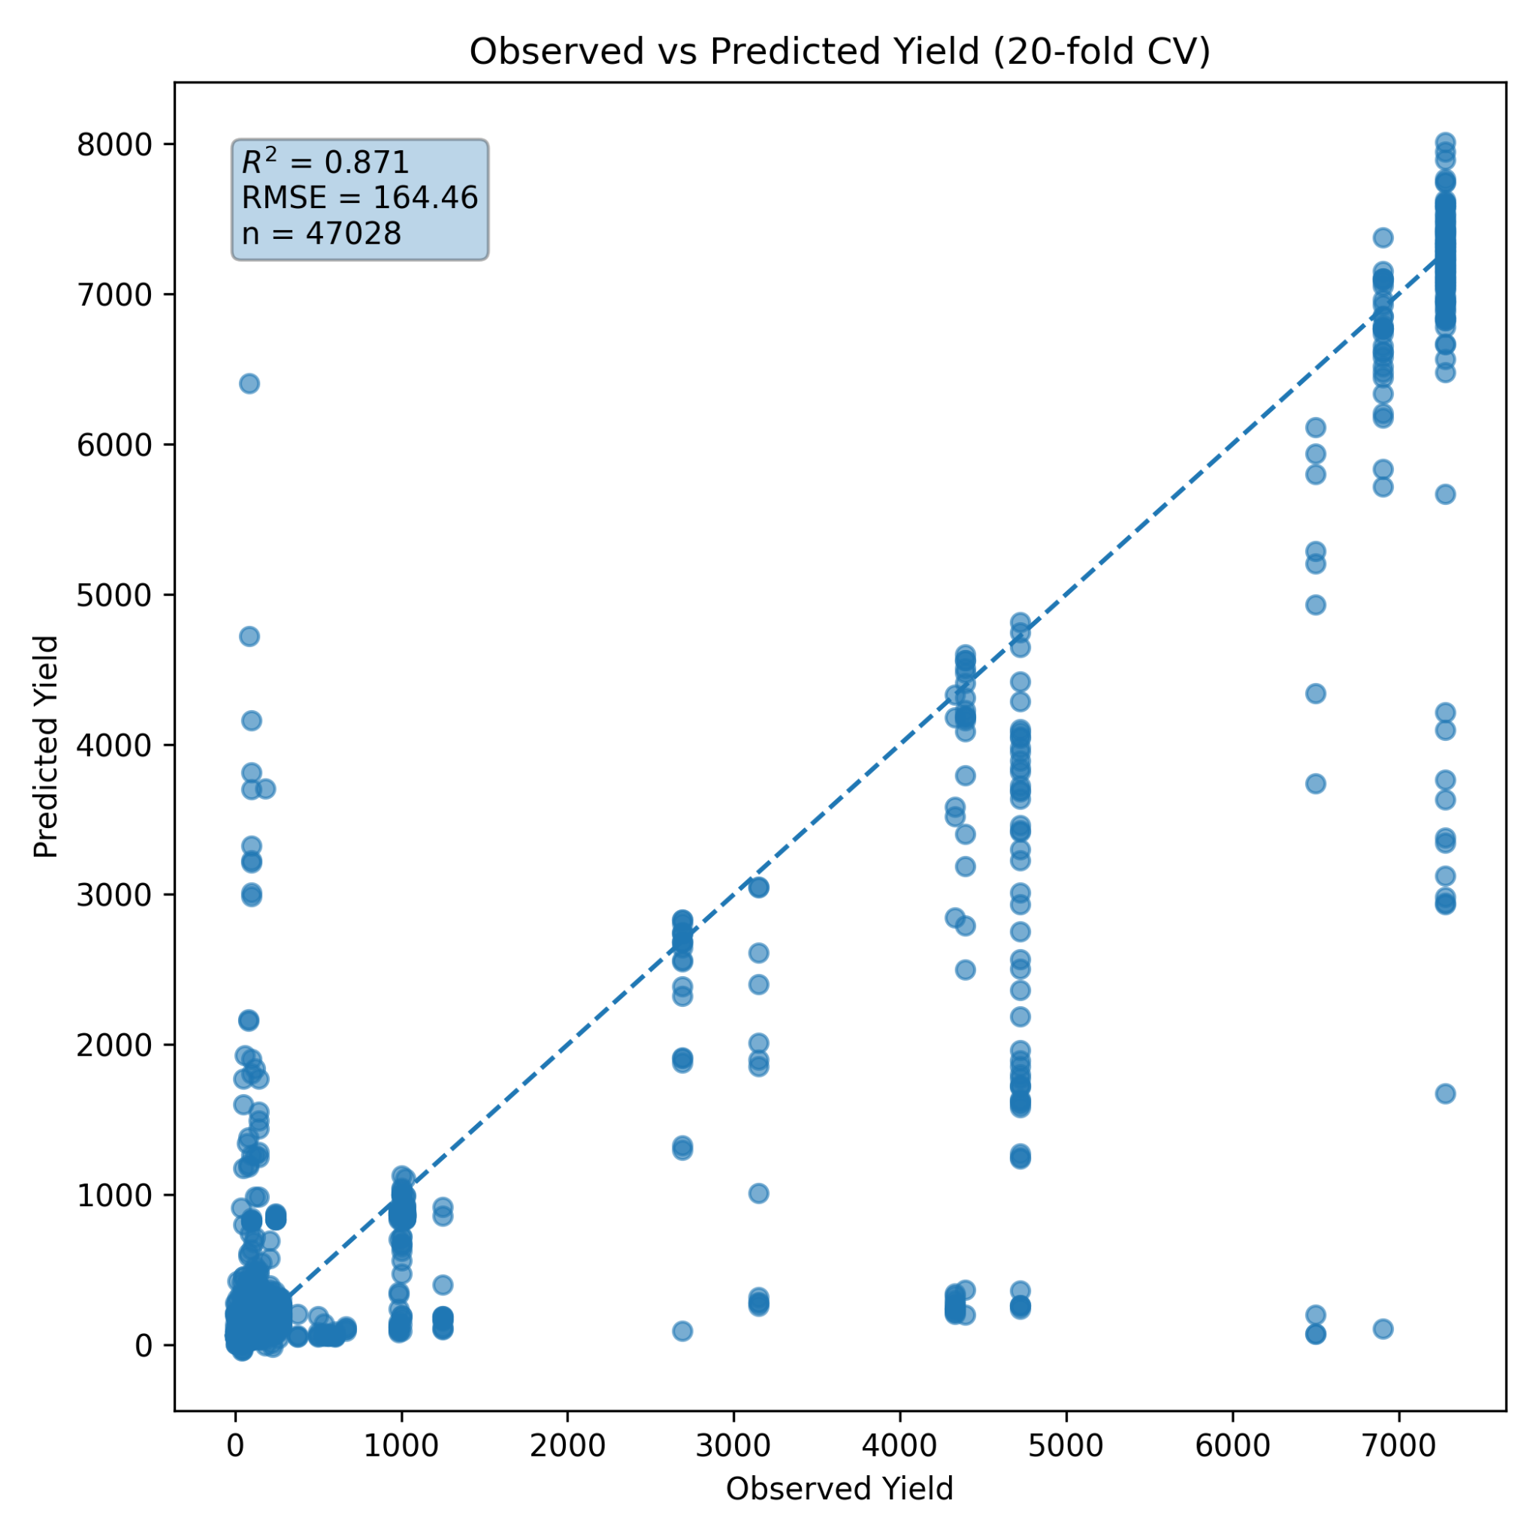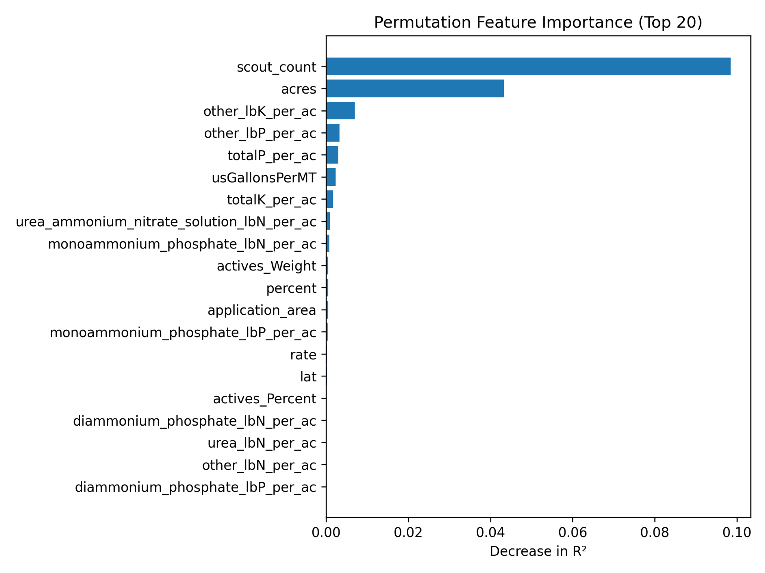
Figure 1: Observed vs Predicted Yield Plot and permutation feature importance
Interpretation:
- 87% of yield variance explained
- Strong predictive capacity across crops and management conditions
- Residual spread indicates good calibration without extreme bias
This performance is comparable to the previous CatBoost model (R² = 0.85).
6. Computational Performance
A major advantage of this architecture:
- Training time ≈ 25 minutes
- No GPU required (runs efficiently on CPU)
- No heavy computational load
- Minimal system strain (no excessive CPU spinning)
- Stable memory usage
This makes the model:
- Lightweight
- Suitable for production backend
- Scalable for batch predictions
Compared to many deep learning architectures (e.g., transformers), this model is computationally efficient and practical for real-world deployment.
7. Model Deployment Package
The following files are generated for backend and frontend integration:
- yield_deep_model.pth (trained neural network weights)
- numeric_scaler.pkl (numerical feature standardization)
- feature_columns.json (required feature order)
- categorical_columns.json (categorical feature names)
- category_sizes.json (embedding dimensions)
- crop_statistics.csv (for back-transformation to original yield)
This ensures:
- Reproducible inference
- Correct preprocessing in production
- Consistent transformation pipeline
8. Feature Importance Interpretation
Unlike tree-based models, neural networks do not provide direct feature importance.
For interpretation, recommended approaches include:
- Permutation importance
- SHAP (DeepExplainer)
- Embedding distance analysis
We utilized permutation importance methods for interpretability reporting.
9. Why This Architecture Was Chosen
This architecture was selected because:
- Dataset size (~47k) is sufficient for deep learning
- Many high-cardinality categorical variables
- Strong nonlinear interactions expected
- Need for scalable production model
- Lightweight computation required
Compared to boosting:
Model | R²
CatBoost | 0.85
Deep Learning | 0.87
The deep model slightly outperformed boosting while remaining computationally efficient.
10. Practical Implications
This model enables:
- Farmer-level yield prediction based on management inputs
- Enterprise-scale batch yield forecasting
- Decision-support tools for fertilizer optimization
- Strategic planning across crops and regions
It forms the predictive engine for the planned software platform.

